Task of IAM- Identification for management
1) Create one IAM user and assign ec2,s3 full access role.
Steps via AWS Console:
- Go to IAM → Users → Create user.
  - User name: user1.
  - Enable Programmatic access and/or AWS Management Console access.
- Attach Policies:
  - AmazonEC2FullAccess
  - AmazonS3FullAccess.
- Complete user creation and download credentials.
AWS CLI:
aws iam create-user --user-name user1
aws iam attach-user-policy --user-name user1 --policy-arn arn:aws:iam::aws:policy/AmazonEC2FullAccess
aws iam attach-user-policy --user-name user1 --policy-arn arn:aws:iam::aws:policy/AmazonS3FullAccess
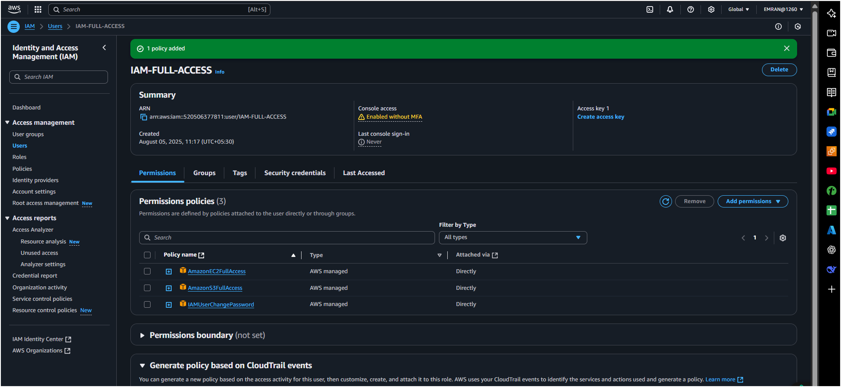

2) Create one Group in IAM and Assign Read access for ec2.
Console Steps:
- Go to IAM → Groups → Create group:
  - Name: EC2ReadOnlyGroup.
- Attach AmazonEC2ReadOnlyAccess policy.
- Save.
AWS CLI:
Console Steps:
- Go to IAM → Groups → Create group:
  - Name: EC2ReadOnlyGroup.
- Attach AmazonEC2ReadOnlyAccess policy.
- Save.
AWS CLI:
aws iam create-group --group-name EC2ReadOnlyGroup
aws iam attach-group-policy --group-name EC2ReadOnlyGroup --policy-arn arn:aws:iam::aws:policy/AmazonEC2ReadOnlyAccess
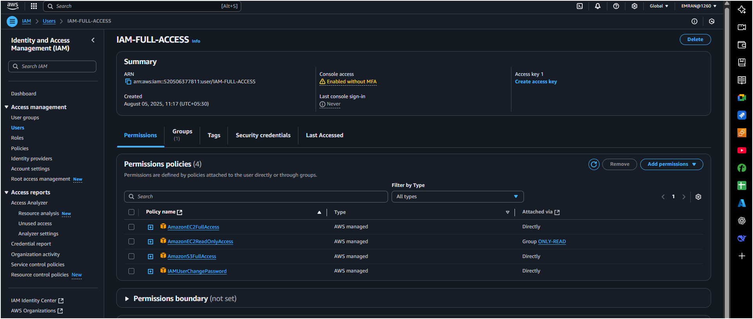
3) Create a new user with name Devops and add to the group created in task2.
Console Steps:
- Create user Devops in IAM.
- Add to group EC2ReadOnlyGroup.
AWS CLI:
aws iam create-user --user-name Devops
aws iam add-user-to-group --user-name Devops --group-name EC2ReadOnlyGroup
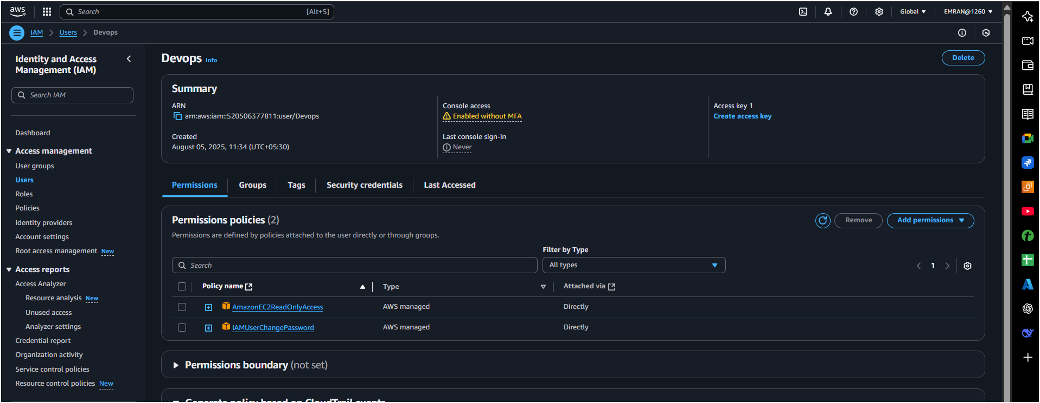
4) Write a bash script to create a IAM user with VPC full access.
#!/bin/bash
read -p "Enter IAM username: " username

# Create user
aws iam create-user --user-name $username

# Attach VPC Full Access Policy
aws iam attach-user-policy --user-name $username --policy-arn arn:aws:iam::aws:policy/AmazonVPCFullAccess

# Create login credentials (optional)
aws iam create-login-profile --user-name $username --password 'Password123!' --password-reset-required

echo "User $username created with VPC Full Access."
Make executable:
chmod +x create_iam_user.sh
./create_iam_user.sh
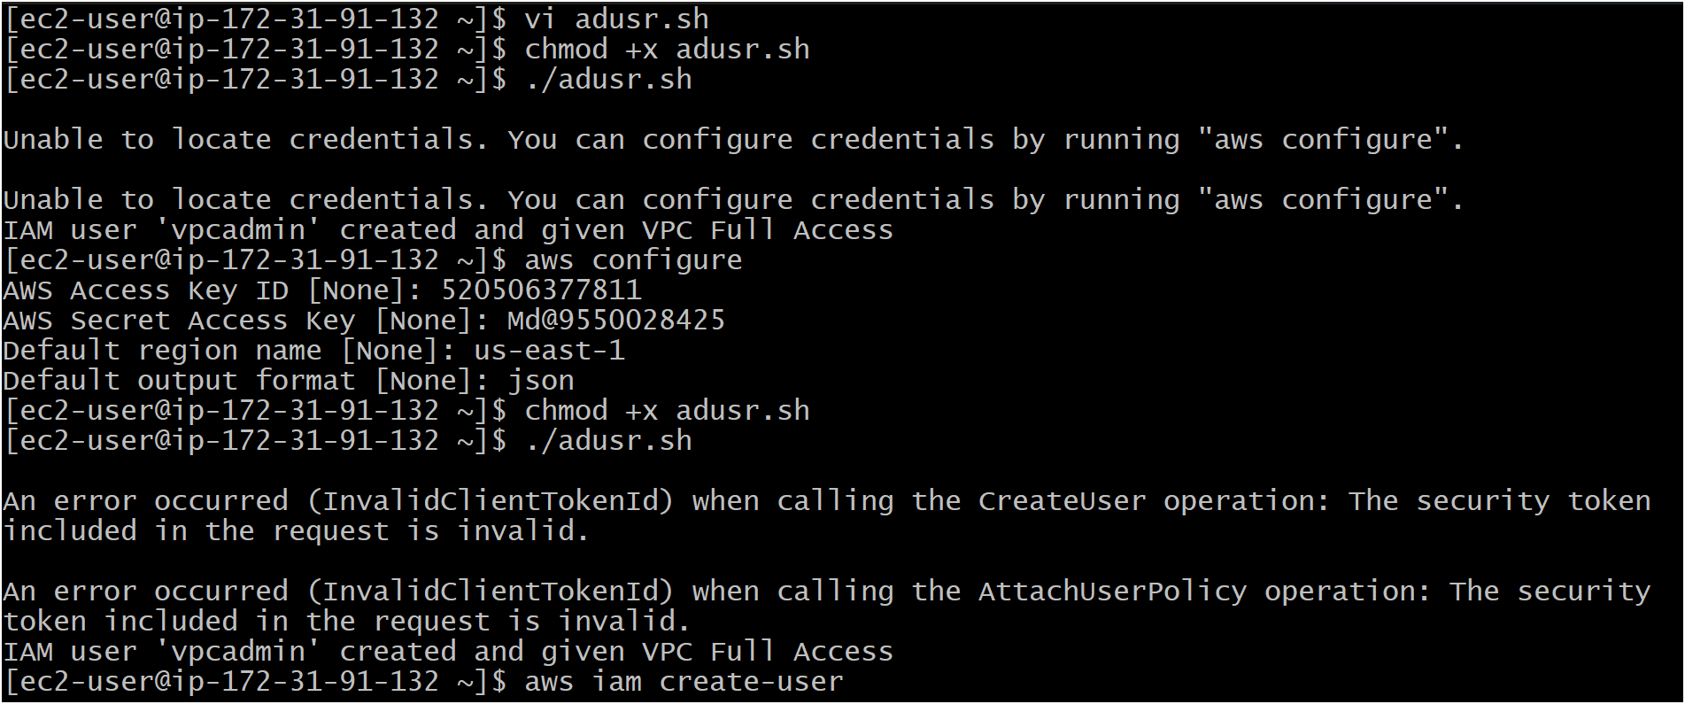
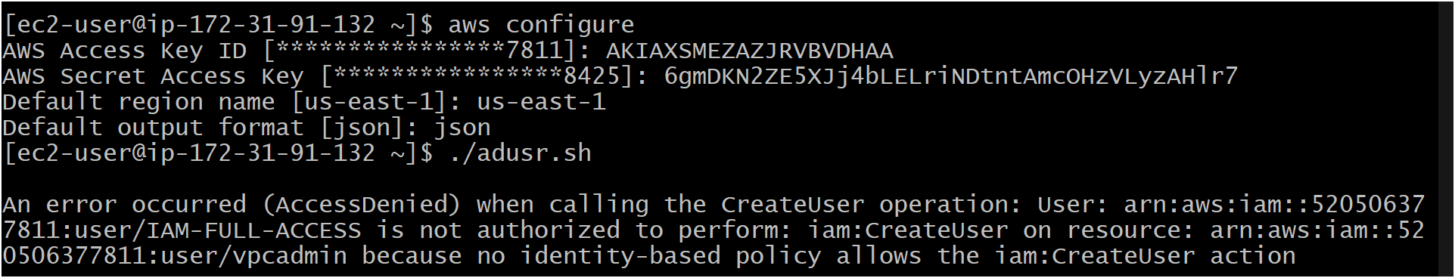
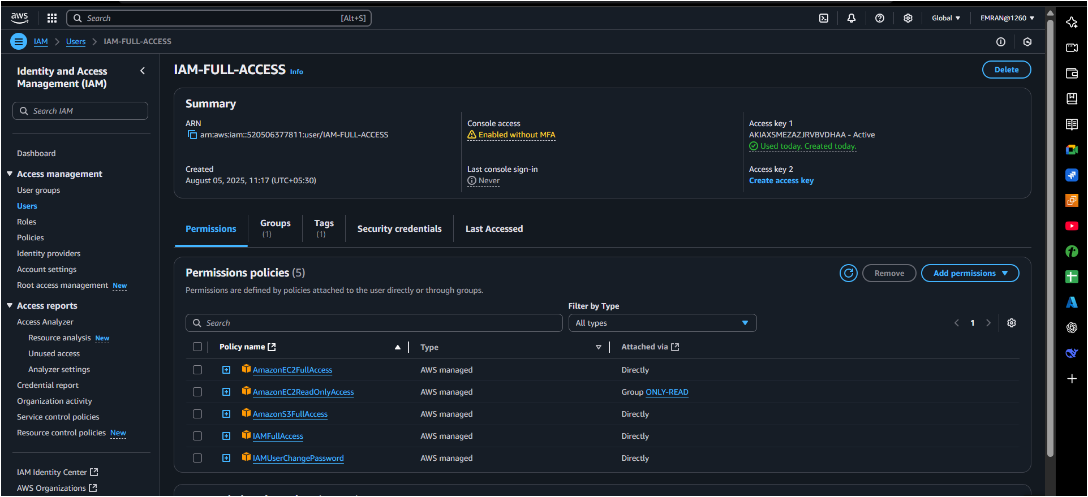
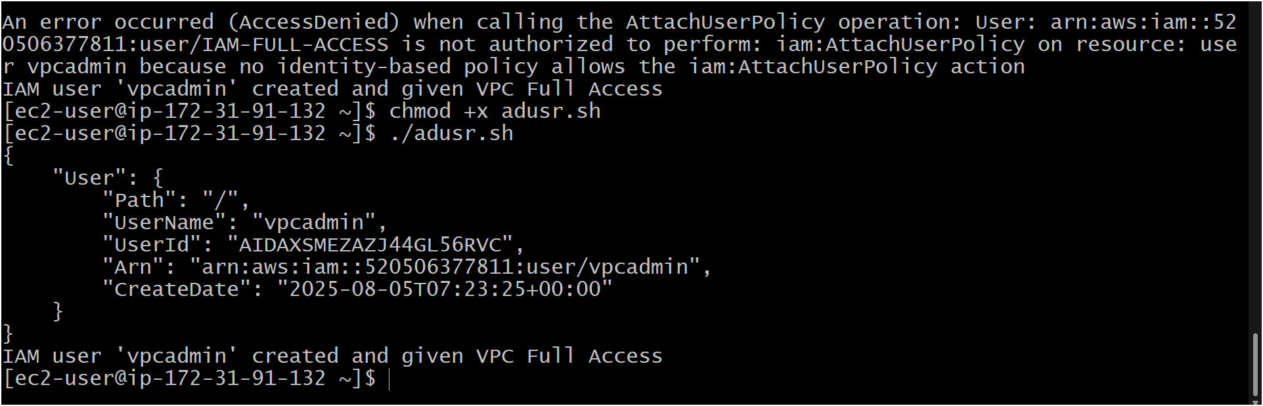
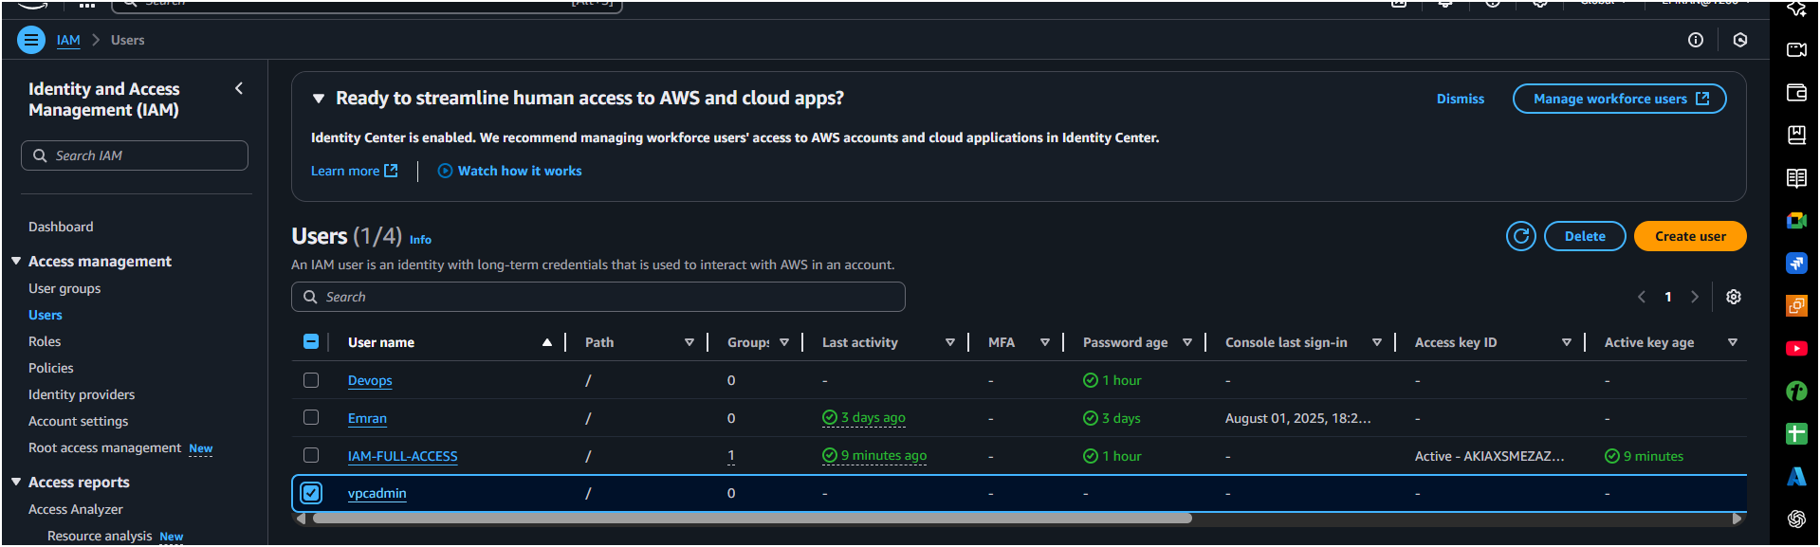
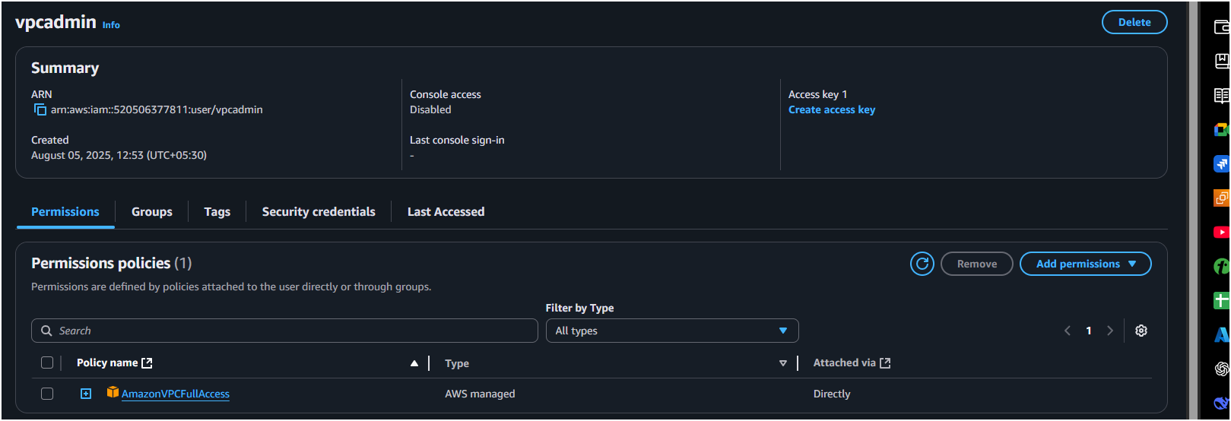

5) Create a IAM policy to access ec2 for a specific user in specific regions only.
Policy JSON Example (Allow EC2 only in us-east-1 and us-west-2):
{
"Version": "2012-10-17",
"Statement": [
{
"Effect": "Allow",
"Action": "ec2:*",
"Resource": "*",
"Condition": {
"StringEquals": {
"aws:RequestedRegion": [
"us-east-1",
"us-west-2"
]
}
}
}
]
}
Steps:
- Go to IAM → Policies → Create policy.
- Switch to JSON, paste the above.
- Save as EC2SpecificRegionPolicy.
- Attach this policy to the specific user.

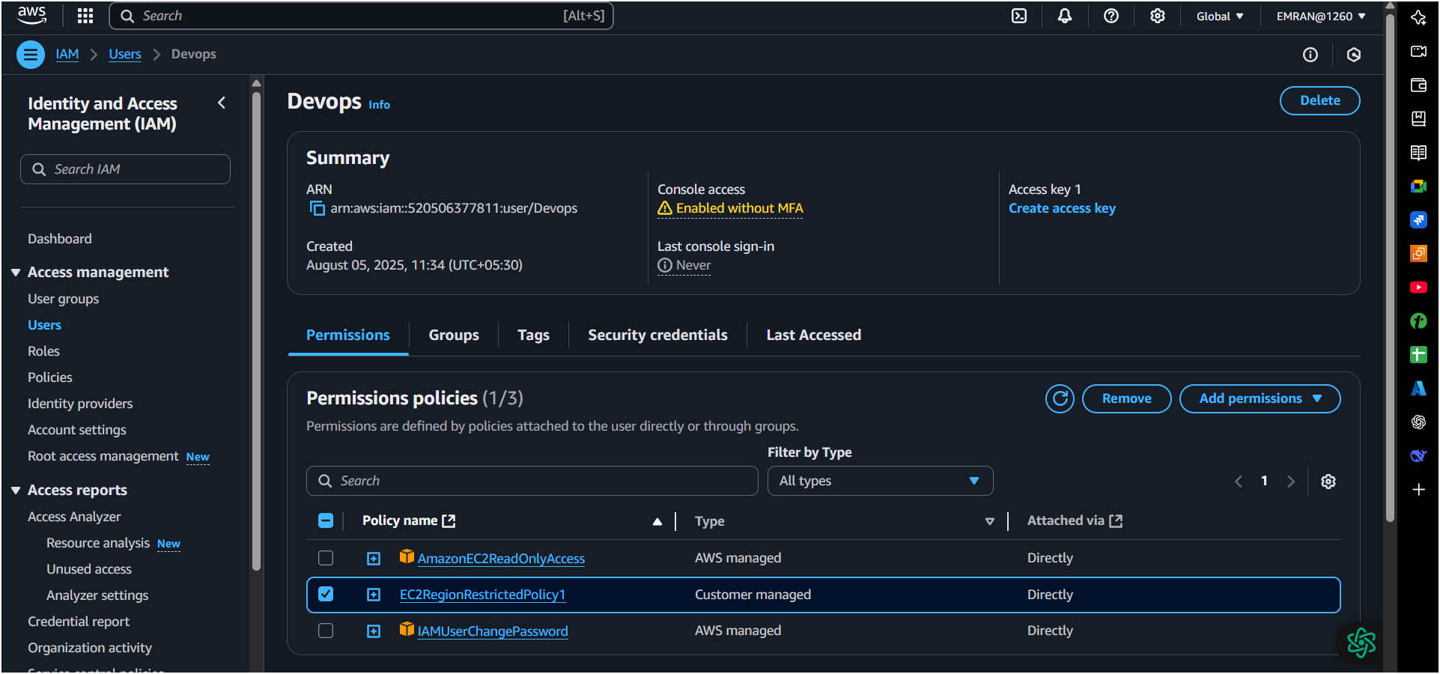
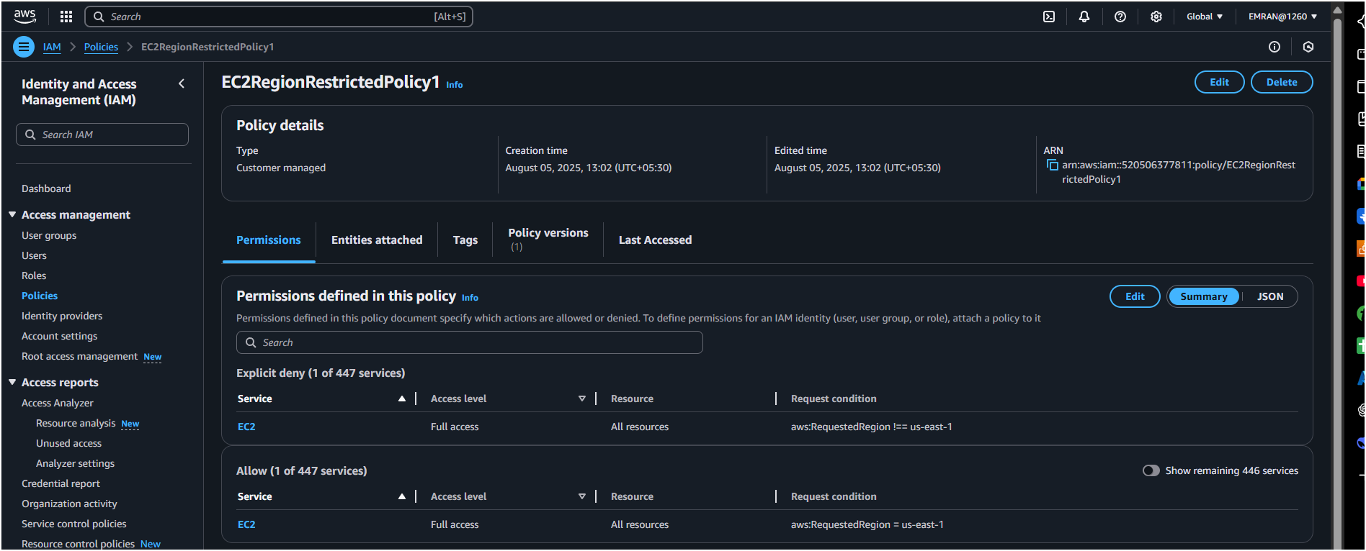
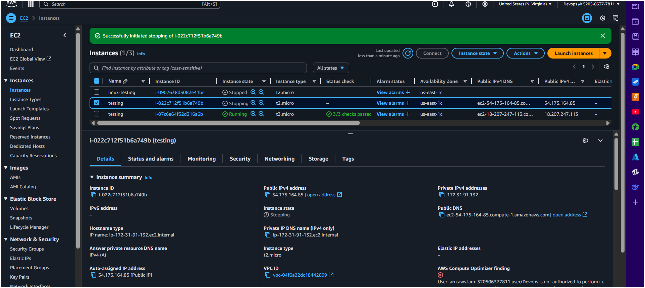

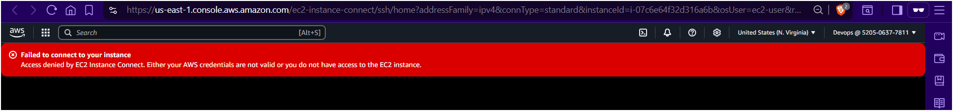
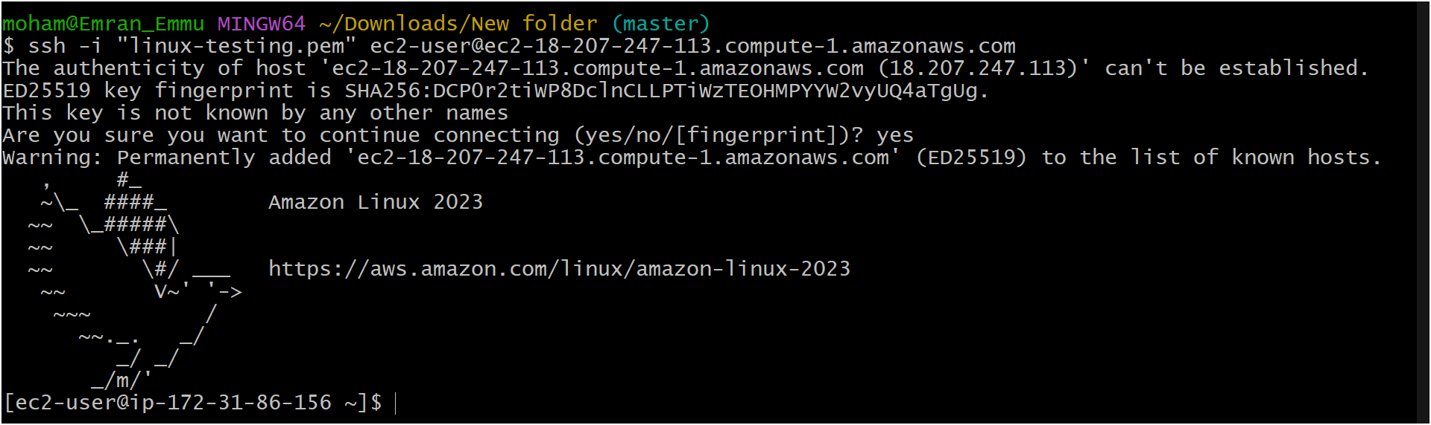

6) We have two accounts Account A and Account B,
Steps:
- Go to IAM → Policies → Create policy.
- Switch to JSON, paste the above.
- Save as EC2SpecificRegionPolicy.
- Attach this policy to the specific user.

- Account A user should access s3 bucket in
- Account B. (Collaborate with team member and execute this.Mostly asked in every interview)
Accounts-A (mine)
- 1ST create a iam user open you user and u will get an option permission policies there you’ll get add permission click on it then you get an option create inline policy
- add this permission/policy in json and save
{
"Version": "2012-10-17",
"Statement": [
{
"Sid": "Example",
"Effect": "Allow",
"Action": [
"s3:ListBucket"
],
"Resource": [
"arn:aws:s3:::np-bucket-s3-iam;"
]
}
]
}
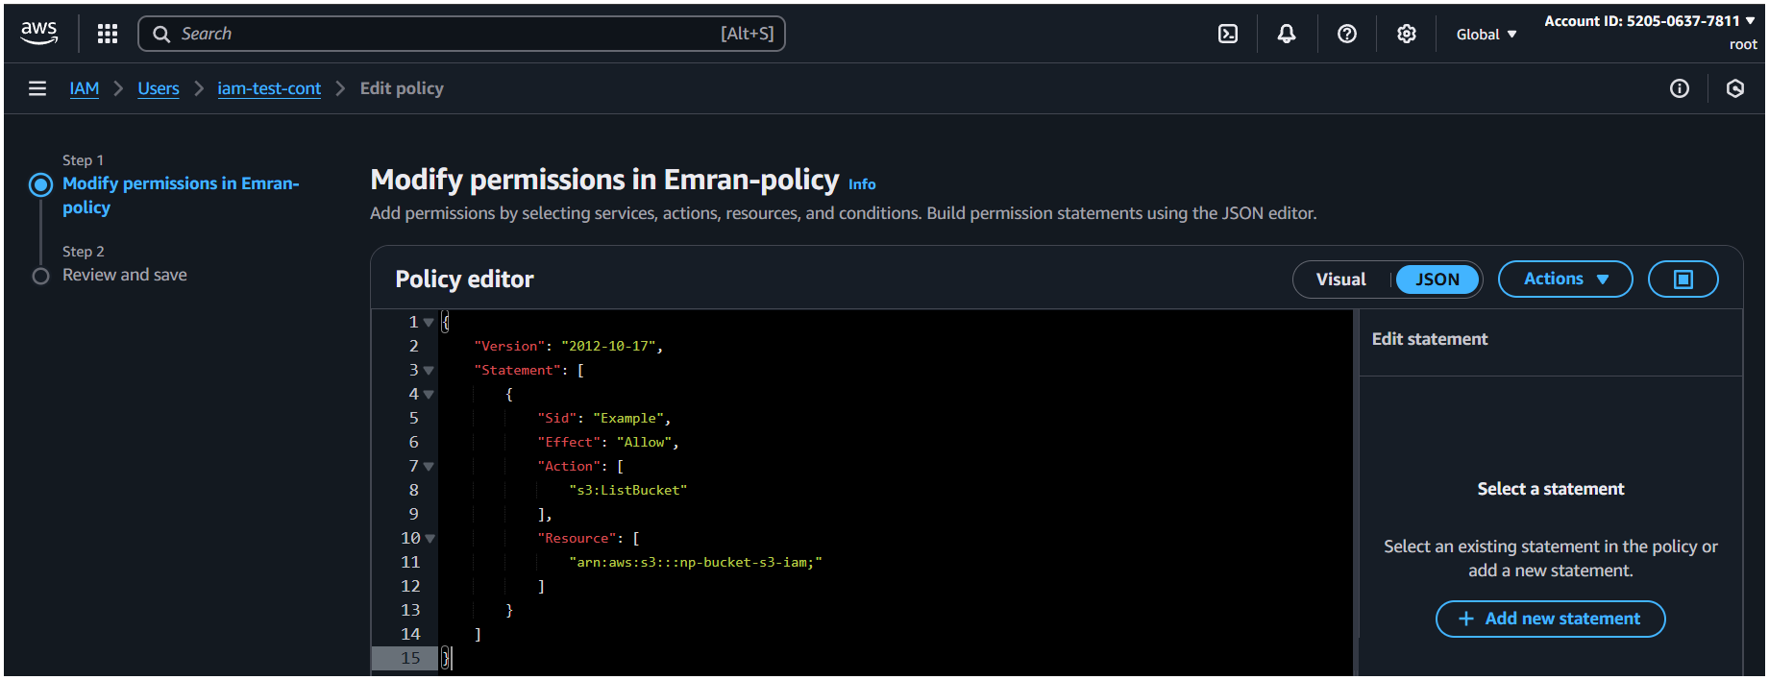
- 2nd create a bucket and in permission add script with ur Aws id and bucket name of your frd
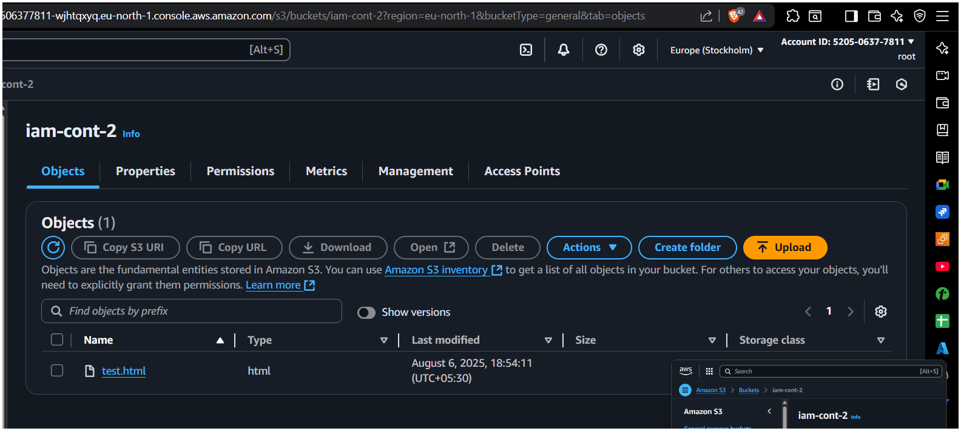
Add this Script/permission/policy
- Add your Frd Aws id and then add your bucket name here in your s3 bucket.

"Version": "2012-10-17",
"Statement": [
{
"Sid": "Example permissions",
"Effect": "Allow",
"Principal": {
"AWS": "arn:aws:iam::216612007883:root"
},
"Action": [
"s3:GetLifecycleConfiguration",
"s3:ListBucket"
],
"Resource": "arn:aws:s3:::iam-cont-2"
}
]
}
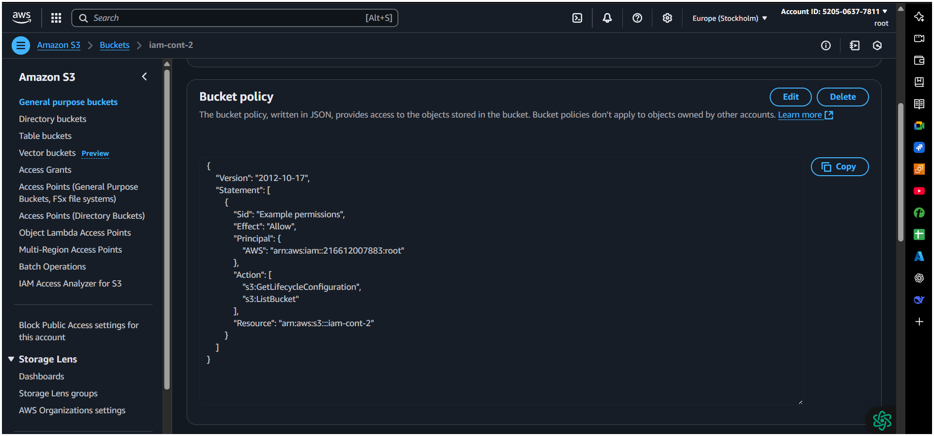
- Open your bash and Type this command and follow the step below
- Aws configure > your access id and password > region (us-east-1) > json >
- Aws s3 ls :- To Check your s3 bucket
- Aws s3 ls s3:// < here your frd s3 bucket name >

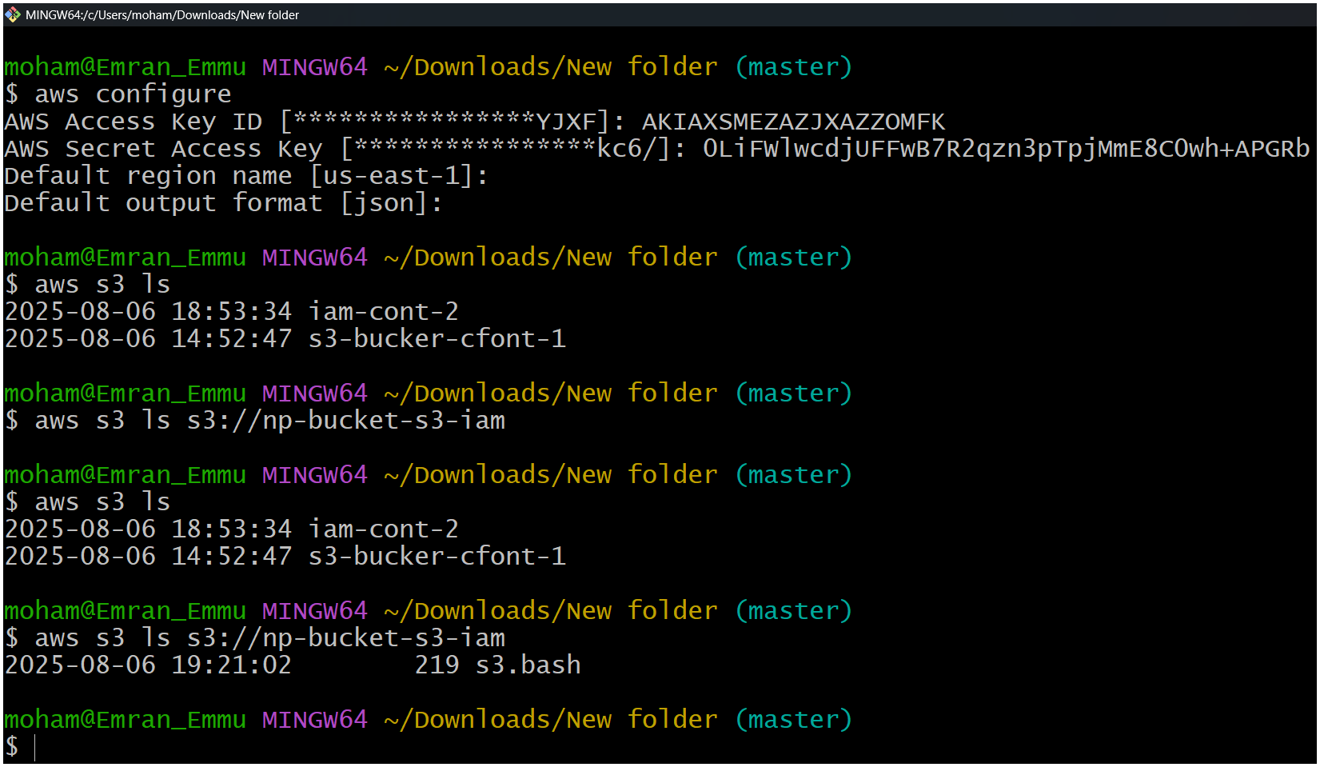
Account -B ( your frd side)
